**QUIZ APP Screen shots**

1.Home Page

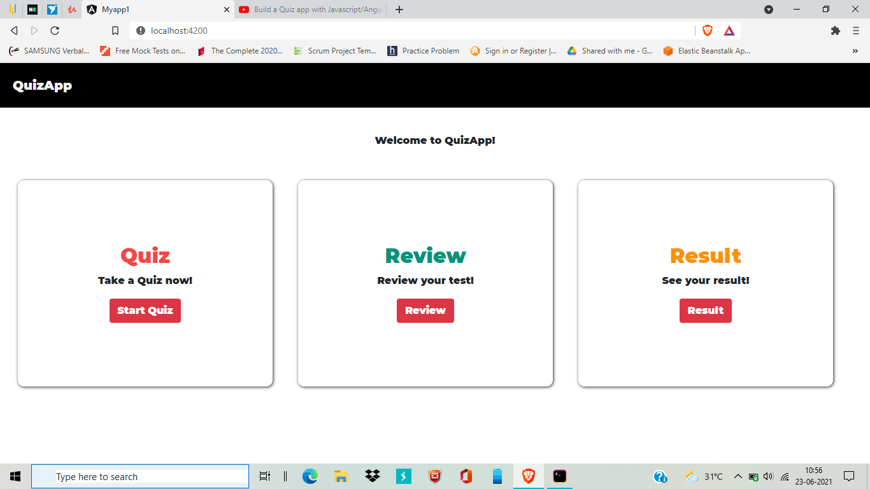

You can see quiz, review and result options

2. You can attend your quiz by clicking on start quiz button

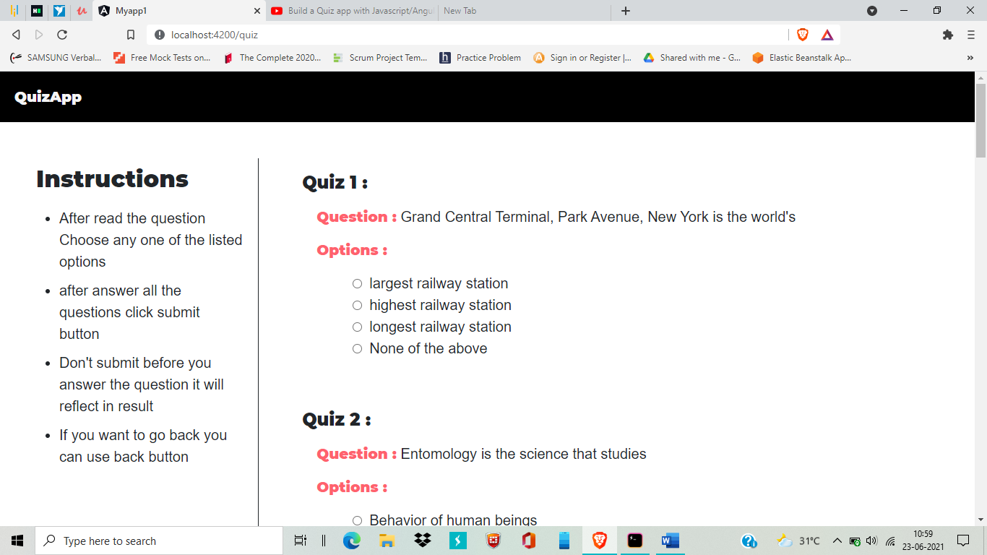

3. After finish your quiz click submit button.

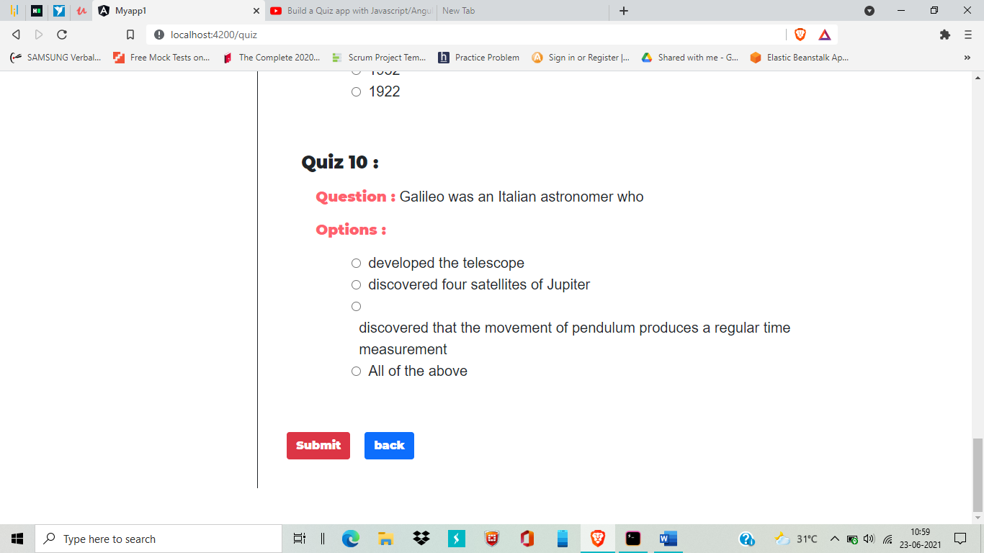

4.After click on submit you will get an alert for successful submission

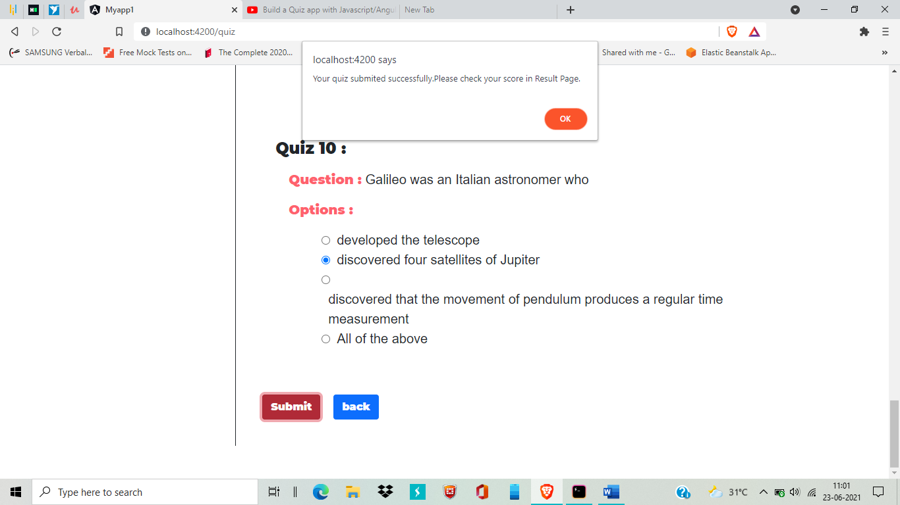

And it will redirect to home page

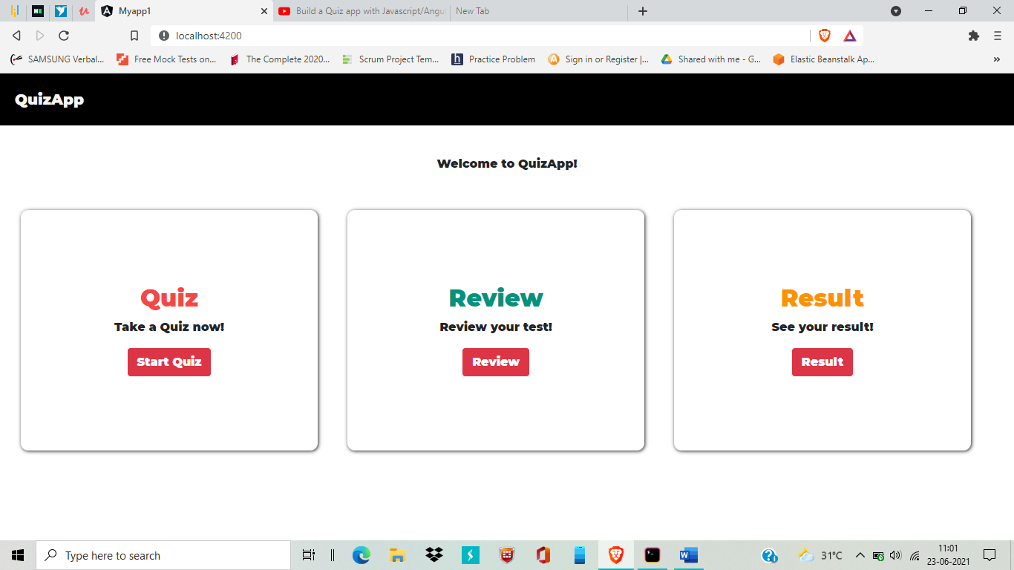

5. Click on Review button to view your questions with correct answers

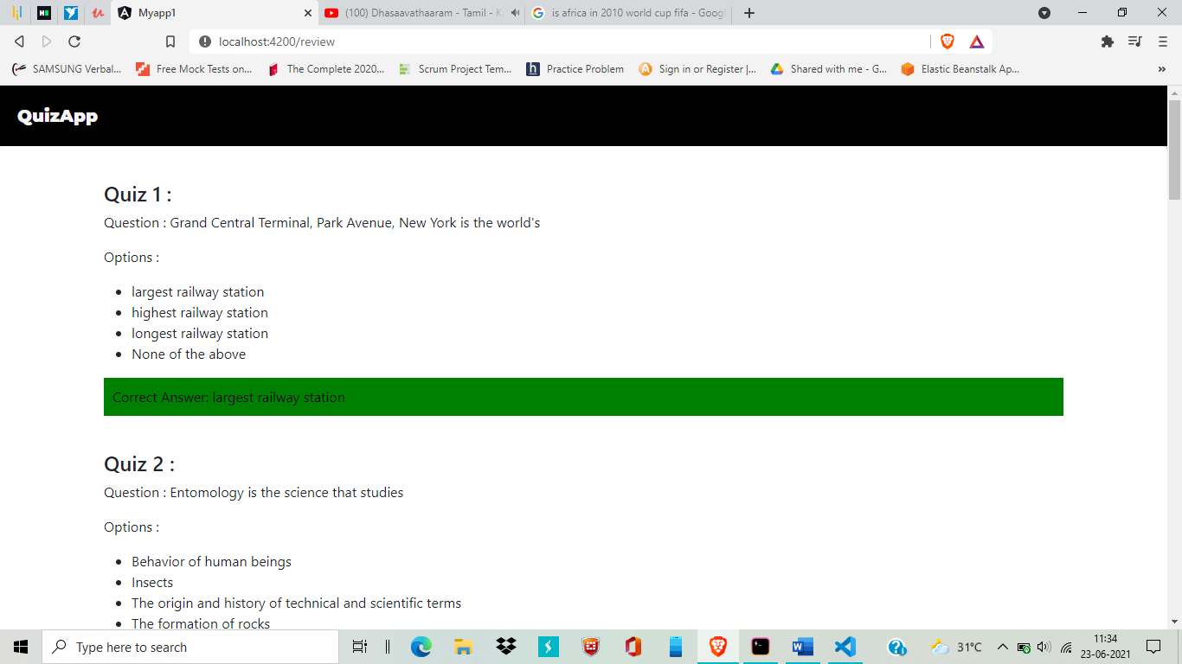

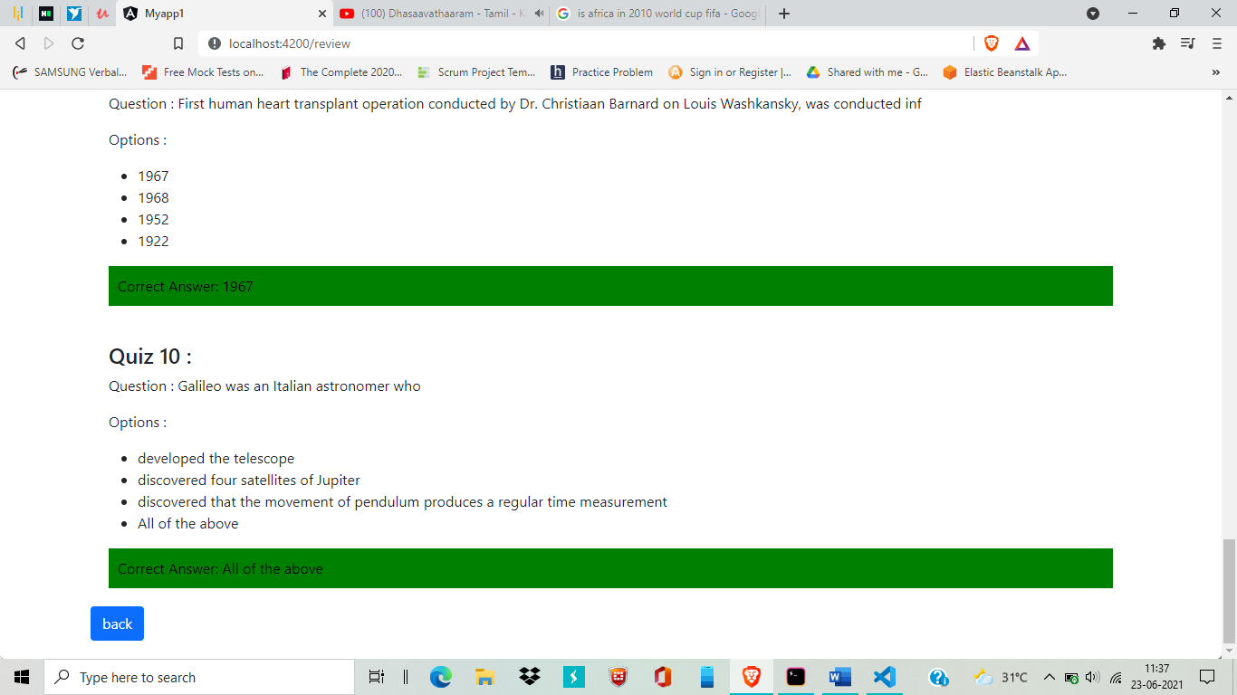

By clicking on back button to return home page

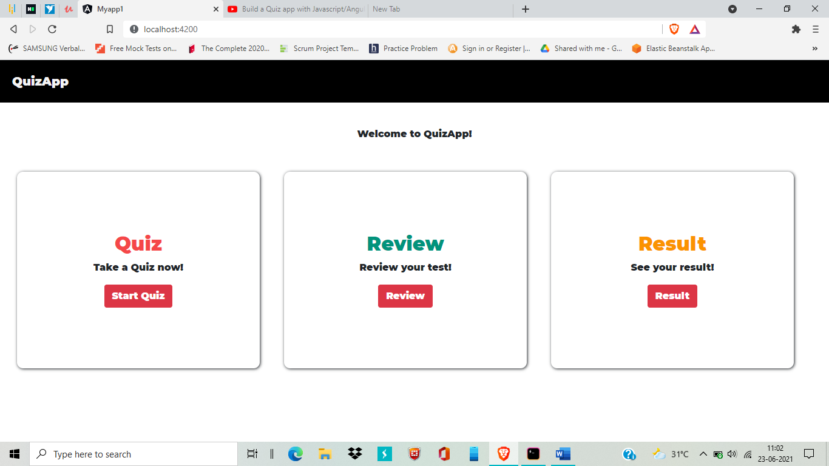

7.Click on Result to you can check your score

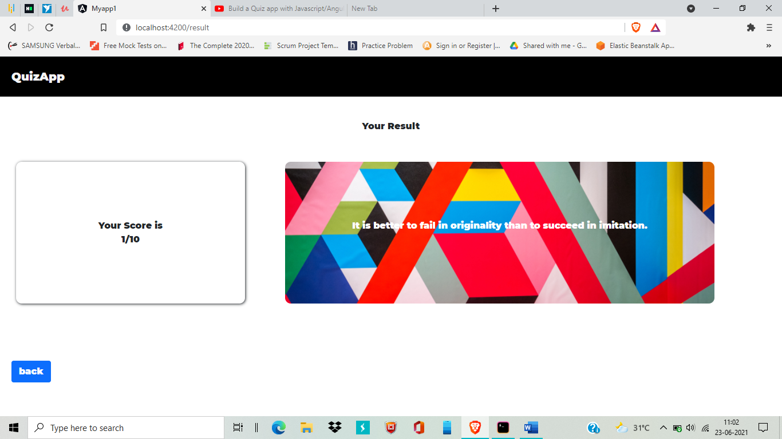

Click on back to redirect to home again



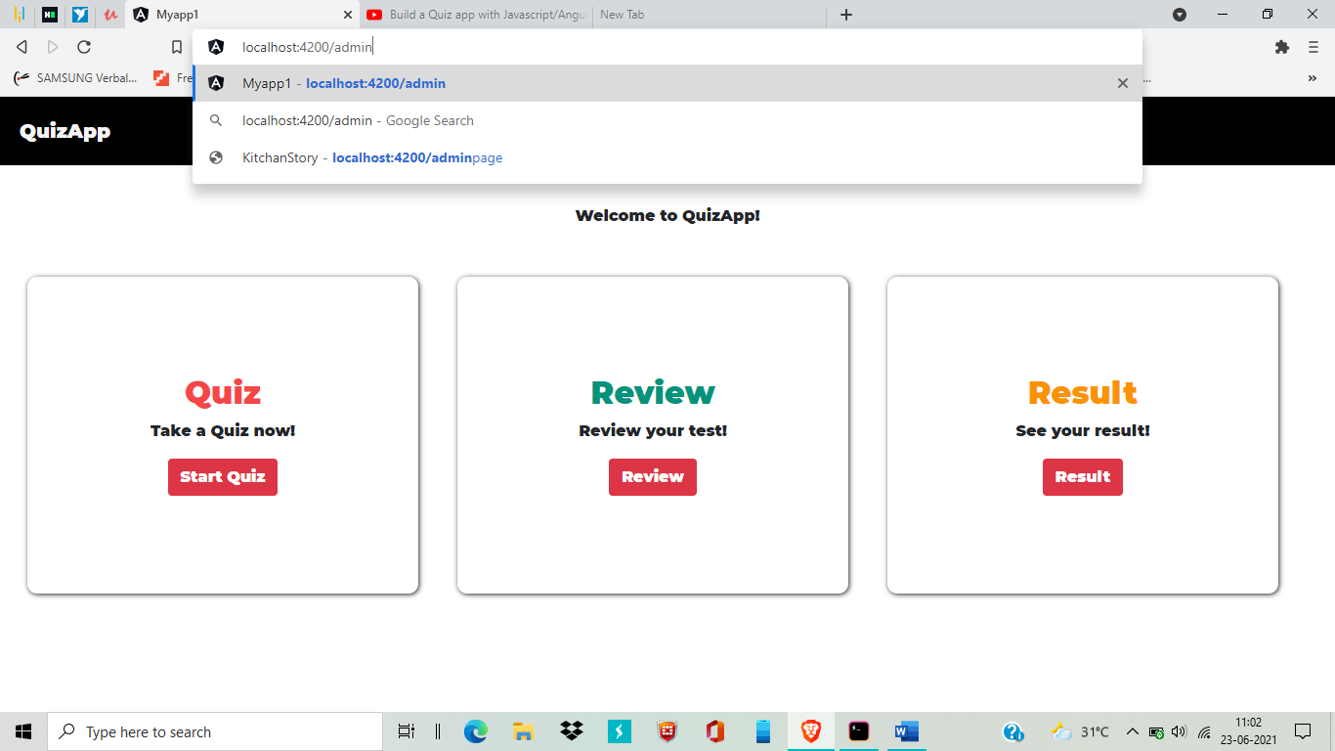

8.add /admin to your home page link will redirect to admin page (http://localhost:4200/admin)

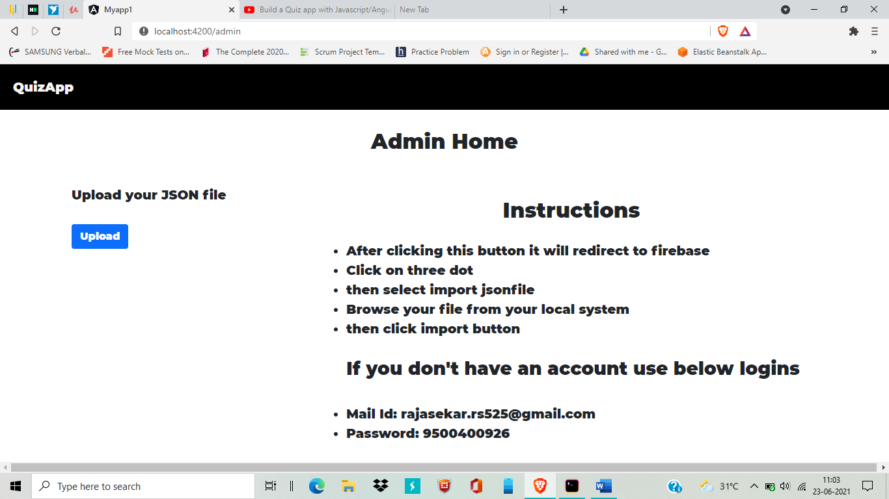

9. In Admin page you have an option for upload a file(Json file),by clicking on upload it will redirect to firebase

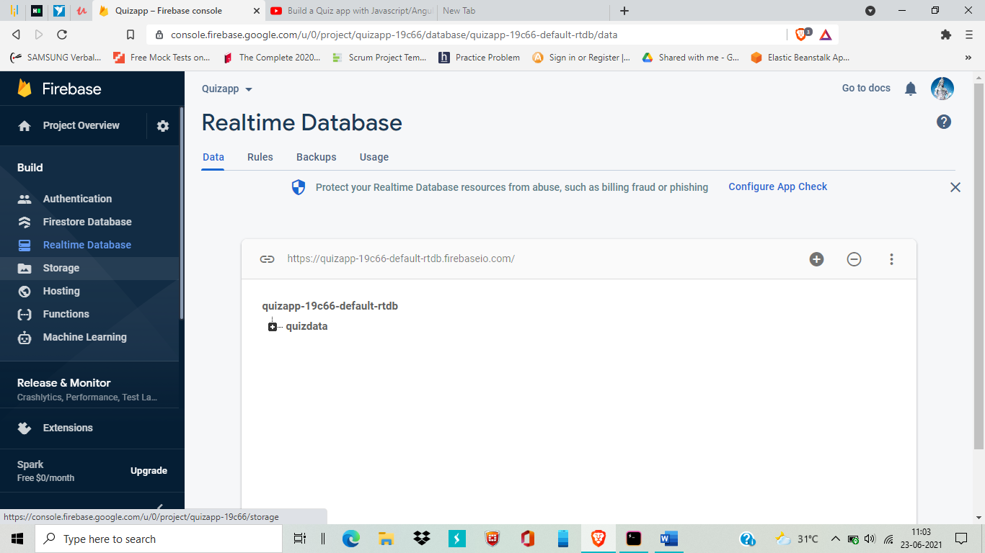

If you already login with my account. You directly get this page(Logins: Rajasekar.rs525@gmail.com,9500400926).

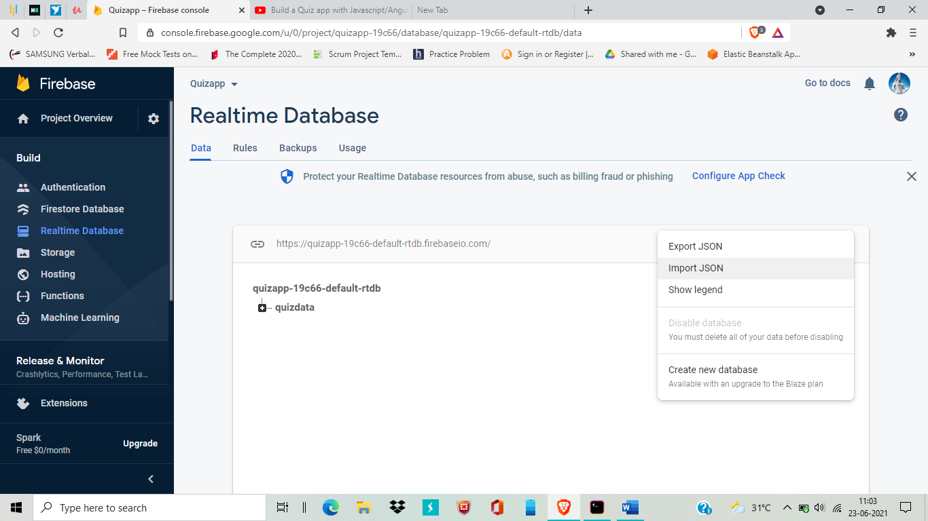

Now click on the three dots present in the right-side corner top. Then select import json option

Now browse your json file from your system by click on Browse option

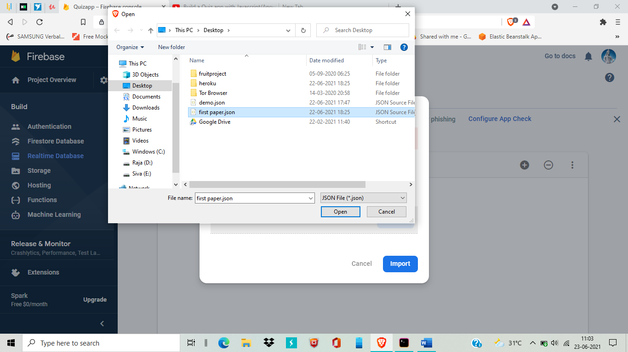

After file selected click open

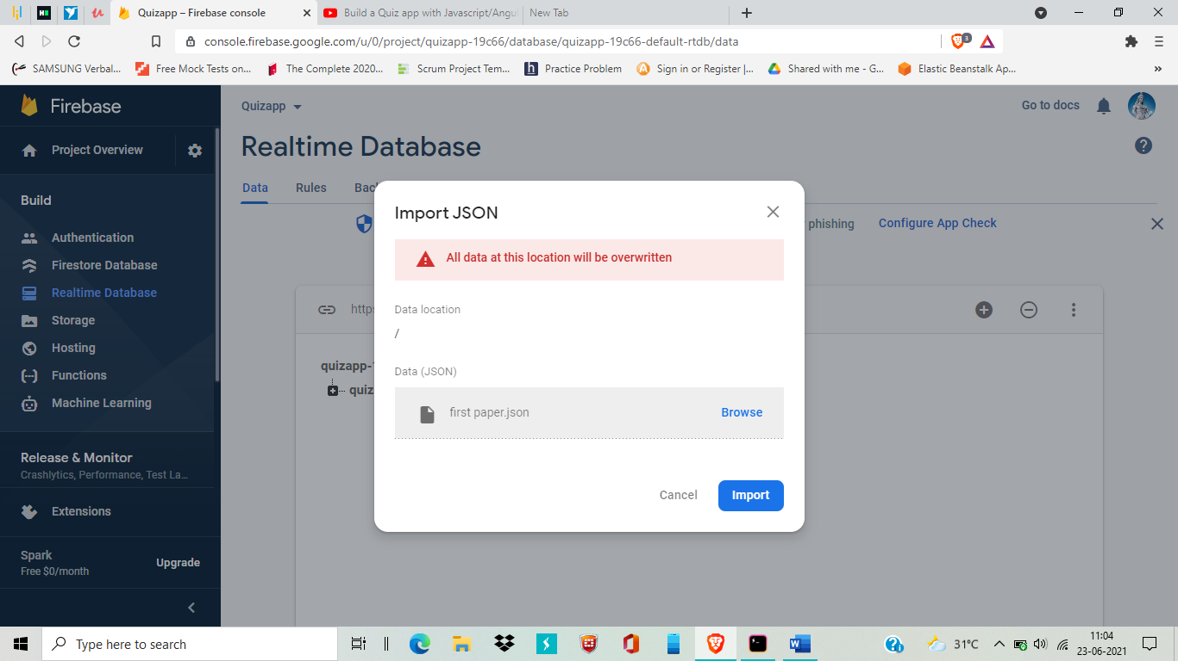

Then click import button

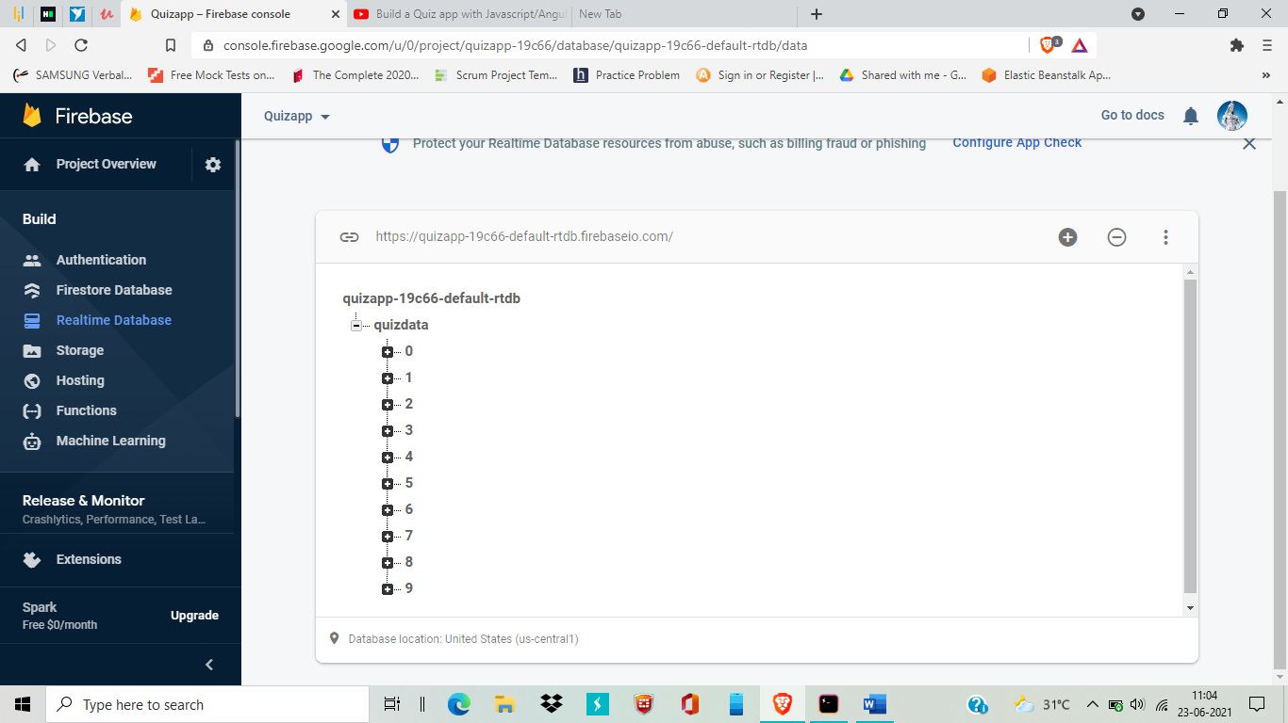

Now file successfully imported. It will automatically reflect in application. Imported file questions will displayed in our application.

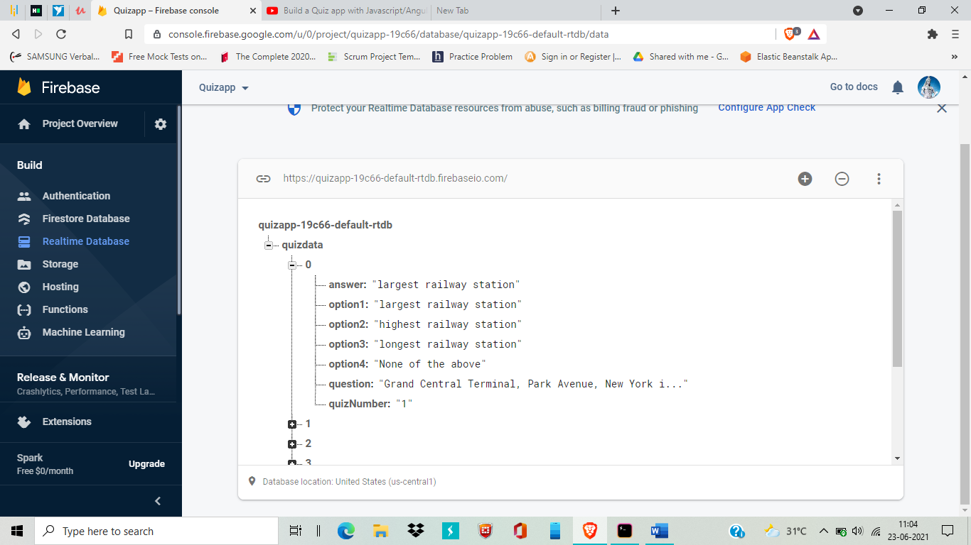

The Json file format it important for this process. I attached it and named as format file.

--------------------------------------------------------------------------------------------------------------------------------------

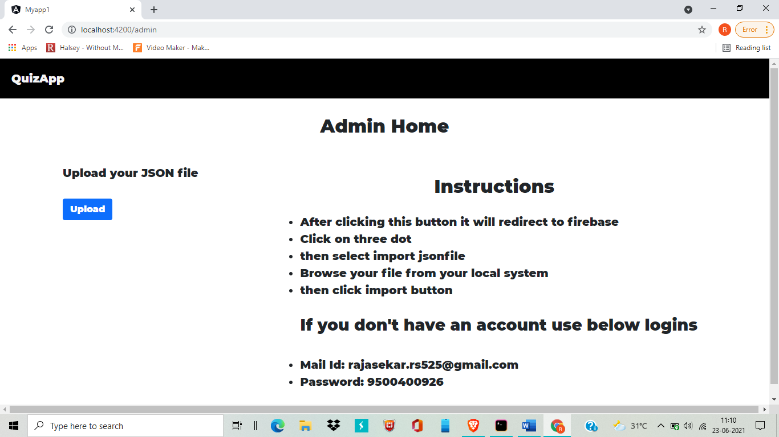

If you are not login with my account in firebase. The application redirect like below

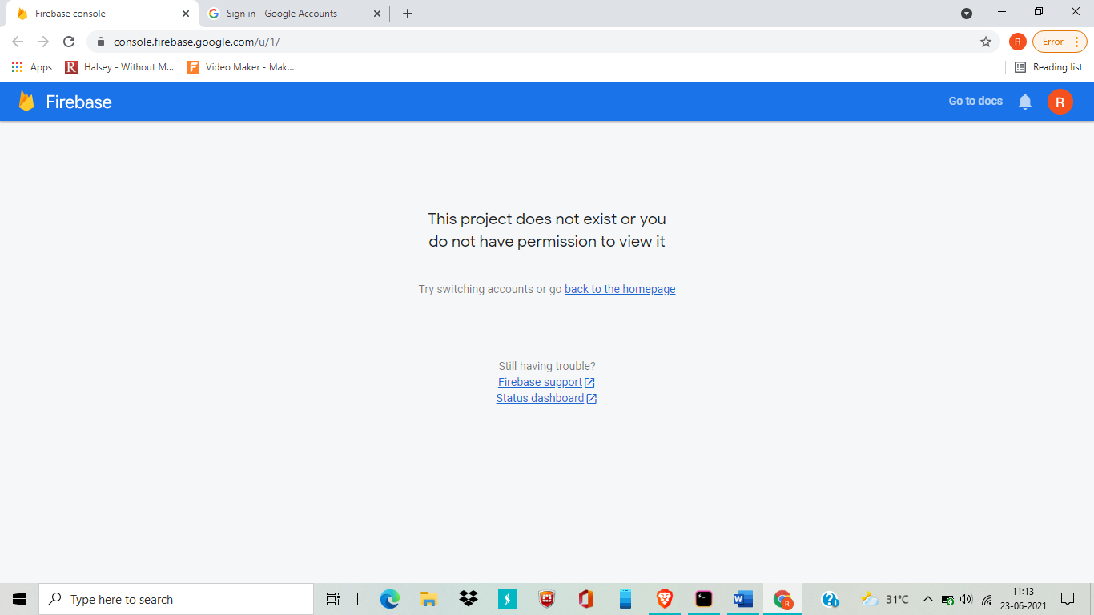

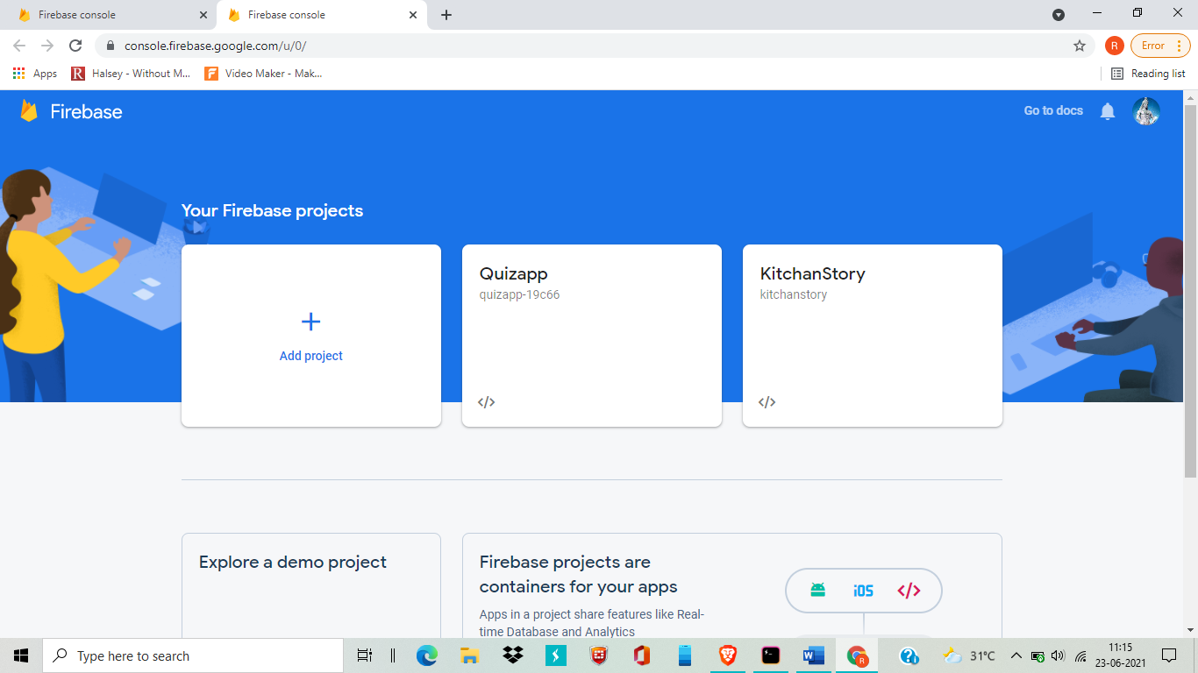

Now you got this home page of firebase **click on Quizapp**

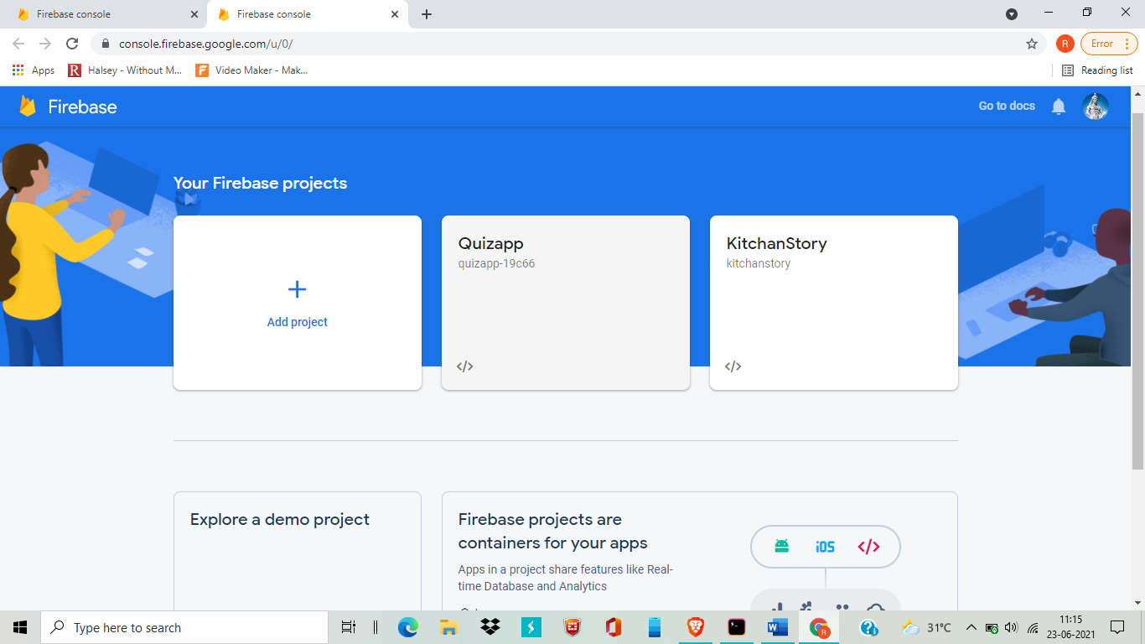

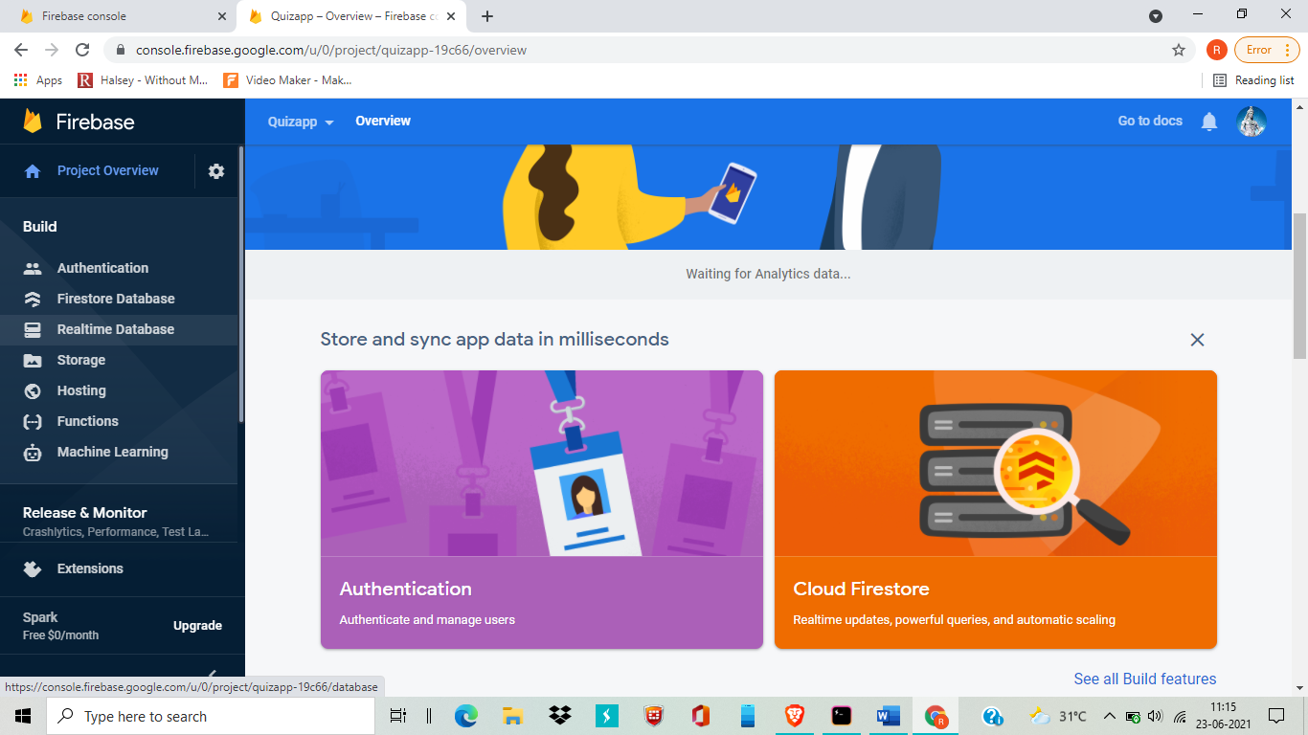

Now select Realtime Database option which listed left inside Build option

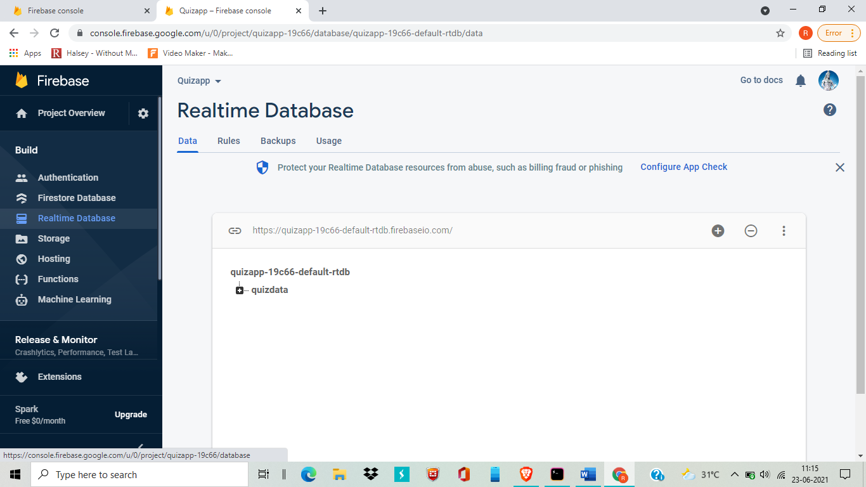

Now you reach the file upload page of firebase by click on three dot you can upload your json file easily.